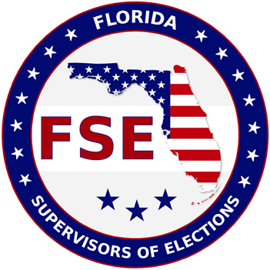
STUDENT ELIGIBILITY GUIDELINES FOR THE
FLORIDA SUPERVISORS OF ELECTIONS SCHOLARSHIP

STUDENT ELIGIBILITY – To be eligible for the FSE Scholarship the student applicant shall:

1. Be a Political Science/Public Administration/Business Administration or Journalism/Mass Communication major.
2. Be a citizen of the United States.
3. Have been a resident of Florida for two years preceding the academic year for which an application is made.
4. Be enrolled or accepted as a full-time student in a senior college or university in Florida. No post-graduate or second- degree students.
5. Be at least a junior in college, or have enough credits for enrollment as a junior prior to the application deadline.
6. Submit two current letters of recommendation: one from the college or university last attended or graduated from; and one from a citizen of good standing in the community.
7. Submit a resume of your high school and/or college activities, as well as, what you have done for your community.
8. Demonstrate a financial need and furnish a financial statement, which shows what your own contribution is to your educational expenses. (Student does not have to submit an official form, can just send a statement of their financial need.)
9. Have maintained a “C” average or above for the previous school year.
10. Be registered to vote. (Written verification required by Supervisor of Elections where student is registered to vote.)
11. Be available for an interview by the Supervisor of Elections in the county where student is registered to vote.

ELIGIBLE INSTITUTION – Scholarship must be given to student attending a Florida university or college, which is accredited by the Southern Association of Colleges and Schools.

STIPULATION – The scholarship check will be made payable to the school where student will be attending.

APPLICATION -

1. Must be received by the Supervisor of Elections in the county the student is registered to vote by March 8, 2023.
2. Letters of recommendation MUST ACCOMPANY APPLICATION OR BE RECEIVED BY THE DEADLINE.

SELECTION – Each county’s Supervisor will review all applications received and select one finalist to be forwarded to the FSE
Scholarship Committee, along with a letter of recommendation for the applicant. The FSE Scholarship Committee will select three winners ($1,200 each) from the finalists submitted by the Supervisors. A student who has received the scholarship award may make a second application the following year.

MAIL OR EMAIL TO: Wakulla County Supervisor of Elections
PO BOX 305
Crawfordville, FL 32326
Wakullacountysoe@wakullavotes.gov

(Eff. 12/23)
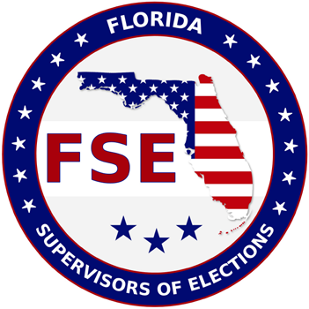
FLORIDA SUPERVISORS OF ELECTIONS

APPLICATION FOR SCHOLARSHIP

I am applying for the FSE Scholarship and

I am enrolled or I have been accepted at:

Name of College or University

1. Name (Mr., Mrs., Ms.): _______________________________________________________________________ Last First Middle
2. Permanent Address:

3. Phone Number ( )
Area Code Number
4. Email:

5. Date of Birth (Month / Day / Year):
6. High School G.P.A.: ______________ College G.P.A.:
7. Junior College/ College/ University from which you were or will be graduated:
8. Current Grade Level Status for Undergraduate College: Junior Senior

Filing this application does not imply that a scholarship will be awarded. It does place the applicant in line for consideration. Scholarship will be awarded only to the applicant who has been accepted at one of Florida’s universities or colleges.

If I accept this scholarship, it is understood that:

I will be a full-time student as defined by the Office of the Registrar. I will be majoring in:
󠇋 Political Science/Public Administration/Business Administration

󠇋 Journalism/Mass Communication

(Scholarship applications may be subject to public records requests)

_________________________________________

Signature of Applicant Date

Please note: Florida has a very broad public records law. All written correspondence to or from government officials is
subject to disclosure to the public and media, upon request, unless otherwise statutorily exempt.

(Eff. 12/23)

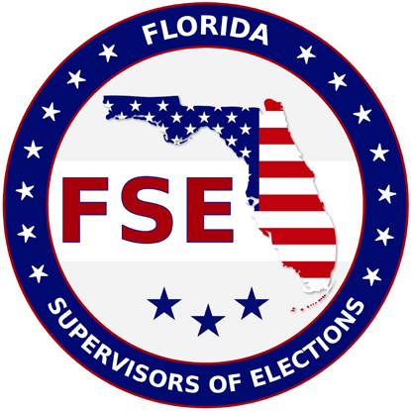
2024 FSE Scholarship

Applicant:

County:

Does student application meet the following requirements?

_____Yes _____ No

_____Yes _____ No

_____Yes _____ No

_____Yes _____ No

_____Yes _____ No

_____Yes _____ No

_____Yes _____ No

_____Yes _____ No
1. Registered voter and a resident of Florida for two years preceding the academic year for which an application is made (Written verification by Supervisor of Elections that student is a registered voter in their county)
(Eff. 12/23)

2. Finished two years of college (junior college/college/university) or enough credits for enrollment as a junior before deadline

3. Currently accepted or enrolled as a full-time student in a college or a university in Florida (Written verification)

4. Political Science/Public Administration/Business Administration or Journalism/Mass Communication major

5. Maintain a “C” average or above for the previous year (school transcripts)

6. Two letters of recommendation: one from college last attended or graduated from and one from a citizen of good standing in the community

7. Resume of high school and/or college activities, as well as community activities

8. Financial need information

